Discovering the Value of  
IBM API Connect 5.0

TEC setup and instructor guide

API Connect V 5.0.0

Contents

TEC Setup instructions 3

Who should be using this document? 3

Hardware Requirements 3

System requirements 3

Connectivity requirements 4

Setting up the software images on your workstation 5

1 Download the Pre-configured PoT image 6

2 Configure the VMWare NAT subnet address 7

3 Open and start the vmx file images 9

Xubuntu 9

Gateway 10

Management 11

API Connect Portal 12

4 User ID and Passwords 15

5 Open Ubuntu Firefox to verify all API components are up 16

Appendix A – Installing OVA from scratch 17

1 Configure the Gateway appliance 18

Install wizard (DataPower IDG v7.5) 18

2 Configure the Management appliance 22

3 Configure the API Cloud Management Console 24

4 Create the Provider Organizations 33

5 Configure the Advanced Developer Portal 37

Congratulations! 47

Appendix B – VMware networking background information 48

Network configuration options 48

Static IP addresses 48

Appendix C - Troubleshooting 49

Binary translation is incompatible with long mode on this platform. Disabling long mode 49

Handy Command Line Interface commands 49

Appendix D - Startup procedures and optional steps to make things easier 50

Appendix E - Enable the Windows host NTP service (optional) 52

Appendix F - VMWare Fusion setup on Mac 54

#### TEC Setup instructions

##### Who should be using this document?

The first section of this document should be used by technical sellers who need to set up a PoT pre-configured environment. The Appendix section of this document describes the installation method and should only be used by technical sellers who need to create a PoT environment from scratch. Generally, these are the circumstances when this is required:

* business controls dictate a need for a licensed version of the code with click-through agreements in the software access catalog so that participants can keep the environment after the PoT session
* participants need to understand how to set up the on-premise environment for services engagements and to conduct PoCs and demos
* participants need to learn how to create organizations and environments

##### Hardware Requirements

For **each participant** you need a minimum of:

* An Intel™ or compatible system consisting of the following components:
  + 1.6 GHz or greater processor
  + 25 GB Hard
  + 12 to 16 GB core host RAM (1.4GB dedicated to image at runtime)
  + Keyboard
  + Mouse
  + Display (image set to 1024x768)
  + Network adapter (not needed at this time)

##### System requirements

IBM API Connect virtual appliances are supported in three hosting environments: VMware, Xen, and IBM PureApplication Systems. It is also possible to use physical appliances for the gateway servers. These instructions use virtual appliances in VMware.

IBM API Management requires three appliances (gateway, management and advanced portal). Each of these appliances requires 4GB of RAM, so a machine with at least 12GB of RAM is recommended to leave capacity for other applications.

Installation can be achieved with 16GB of RAM if you reduce the RAM allocated to each image in VMware. This has been tested with the following settings:

* Gateway server: 4GB RAM
* Management server: 4GB RAM
* Portal: 2GB of RAM
* 1 CPUs and 2 cores per CPU on each virtual machine

In production, you would scale to use more than one of each appliance; however one of each appliance is sufficient for a demo cloud.

##### Connectivity requirements

There are two network options with API Connect version 5. First is the recommended non Dynamic DNS option and second is the legacy Dynamic DNS option. If non-Dynamic DNS is used, then there are no specific DNS or network requirements to run API Management on your laptop. We will use the recommended approach in this PoT.

* The virtual network setting is set to NAT for both the API Management and DataPower Gateway VMs.
* NTP must be set up on the host OS of the machine hosting the VMs or the Ubuntu image. See Appendix E if you need NTP on the host OS.
* The hypervisor (VMWare) needs the NAT subnet to be 192.168.225.0
* The host workstation needs to be on the network with access to the Internet.

###### Load Balancing

This document is targeted to an IBM API Connect cloud on a laptop for demo and educational purposes so we will assume only one DataPower appliance will be used and external load balancing across multiple DataPower appliances is not required. For configurations that include load balancing of multiple DataPower appliances see Appendix A. Note selecting “No load balancer” means that you cannot add a second Gateway server later.

###### Static IP addresses

The following static IP addresses will be used for the IBM API Management appliances.

|  |  |
| --- | --- |
| Description: sign-troubleshooting | It is important to check that these IP Addresses are in the correct range for static IP addresses on your VMware NAT network adapter. See **Appendix B – Troubleshooting** for details. |

|  |  |  |
| --- | --- | --- |
| **Purpose** | **IP Address** | **Host Name** |
| Management | 192.168.225.100 | https://mgr.think.ibm/apim/ |
| Gateway | 192.168.225.52 (eth0) | <https://dp.think.ibm:9090> |
| Portal | 192.168.225.20 | <https://developer.think.ibm> |
| Host OS | 192.168.225.10 | xubuntu-vm |

##### Setting up the software images on your workstation

When setup is complete, the software components of this PoT will include the student’s Windows workstation (host), a virtual machine that represents the API Connect Gateway nodes (IBM DataPower Gateway), a virtual machine that represents the API Connect Cloud Management console node, API Connect Portal and an Ubuntu based virtual machine that has the NTP server, SMTP server, browser, and other components preconfigured.

This document will guide you through the steps to setup a single student workstation image. In summary, you will need to:

* Download the PoT image
* Configure the VMWare NAT subnet address
* Install the pre-configured DataPower, API Connect, and Developer Portal virtual machines
* Install the preconfigured Ubuntu Linux virtual machine

#### 1 Download the Pre-configured PoT image

1. Download the following PoT image (v5) from the following site –

<ftp://pokgsa.ibm.com/gsa/pokgsa/home/m/a/malley/apim5/>

#### 2 Configure the VMWare NAT subnet address

Note that you can check or update your default gateway and DNS server in VMWare Workstation using this procedure with VMware Workstation V10. The following steps guide you through setting the VMWare NAT subnet IP address on a Windows laptop. For instructions on Mac, please refer to the Appendix

1. In VMWare Workstation, open the virtual network editor**: Edit🡪Virtual Network Editor**…
2. In the list of networks, select VMnet8 (type = NAT). In the illustration below the subnet is not correctly set yet.

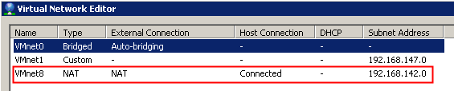

1. At the bottom of the dialog window, change the Subnet IP to: 192.168.225.0.

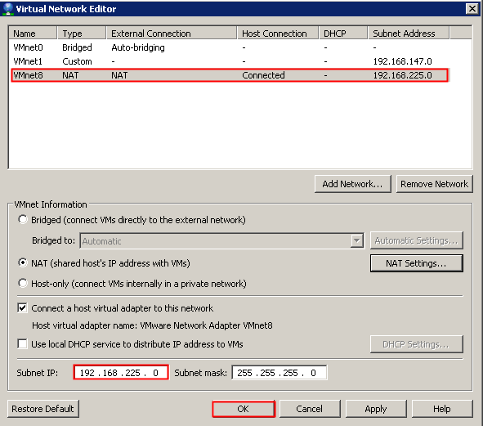

1. Click the **NAT Settings …** button to confirm that the Gateway IP is now set to **192.168.225.2** automatically.

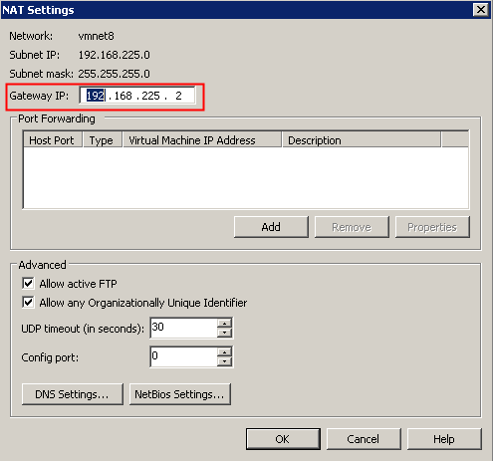

1. Click the **OK** button twice to exit out of the Virtual Network Editor.

#### 3 Open and start the vmx file images

**Startup Sequence**

Start the images in the following Sequence –

1. Xubuntu
2. Gateway
3. Management
4. Portal

##### Xubuntu

1. There are 11 ubuntu zip files. Unzip the first Ubuntu file - Host OS Ubuntu 64 bit.zip.001.
2. Right Click the first of the11 ubuntu zip files, and unzip using a zip utility (winzip or 7-zip).
3. Go to VMWare Workstation. File 🡪 Open 🡪 Locate the vmx file that was unzipped (Host OS Ubuntu 64 bit.vmx).
4. You may be prompted with the following message, select “Take Ownership”.

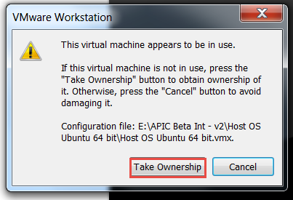

1. Right Click on the image, and click settings. Change the configuration on each Network Adapter from Bridged to **NAT**.

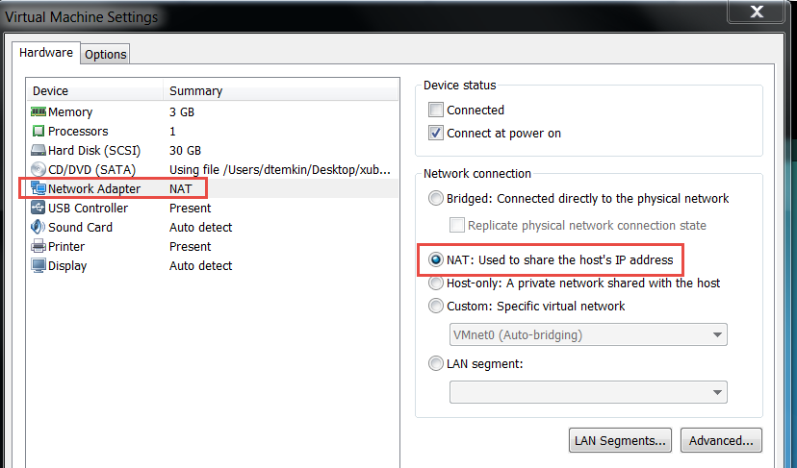

1. Power on the virtual machine (it will take a few minutes to boot, but you can continue with the next steps while you wait). **Select “I moved it” when prompted with if the image was copied or moved.**

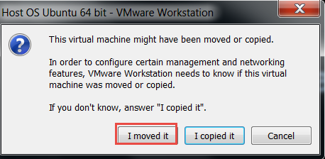

##### Gateway

1. Unzip the Gateway zip file (DataPower-IDG-7.5.0.0.zip).
2. Go to VMWare Workstation. Go to File 🡪 Open 🡪 Locate the .vmx file (DataPower-IDG-7.5.0.0 20160330.vmx). Click on Open.
3. Right click the vmx file, and click on settings. Change the configuration on each Network Adapter from Bridged to **NAT**. Note you only need to do this for eth0 and eth1, but it’s easier to do it for all 4 network adapters in case you want to configure more interfaces in future.

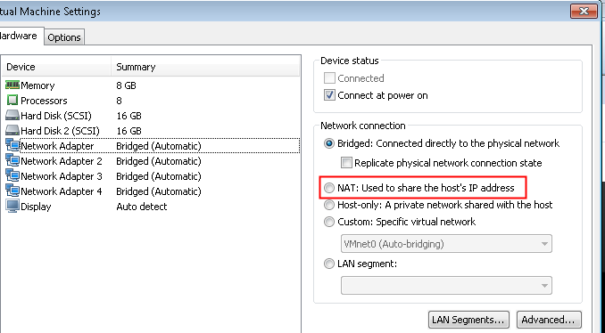

|  |  |
| --- | --- |
| Description: sign-info | According to the DataPower 7.5. Virtual Edition [announcement letter](http://www-01.ibm.com/common/ssi/ShowDoc.wss?docURL=/common/ssi/rep_ca/4/897/ENUS216-024/index.html&lang=en&request_locale=en), the minimum supported configuration is 4GB RAM and 4vCPUs, however if you have restricted resources on your machine you can reduce these now to the amounts in the [System requirements](http://www-01.ibm.com/common/ssi/ShowDoc.wss?docURL=/common/ssi/rep_ca/4/897/ENUS216-024/index.html&lang=en&request_locale=en#etechinfx) section.  There are issues where DataPower will reboot itself if this is reduce below 2GB RAM. |

1. Power on the virtual machine (it will take a few minutes to boot, but you can continue with the next steps while you wait). **Select “I moved it” when prompted with if the image was copied or moved**

##### Management

1. There are 5 management zip files. Right click on the APIConnect_Management_5.0.0.0_20160321-2040_adc87c5ec0a4_c45501c.zip.**001** file, and unzip using a zip utility (winzip or 7-zip).
2. Go to VMWare Workstation. File 🡪 Open 🡪 Locate the vmx file that was unzipped (APIConnect_Management_5.0.0.0_20160321-2040_adc87c5ec0a4_c45501c.vmx).
3. You may be prompted with the following message, select “Take Ownership”.

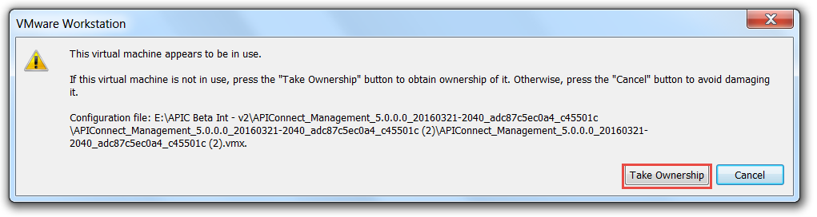

4. Right click the vmx and click settings. Change the configuration on the Network Adapter from bridged to NAT.

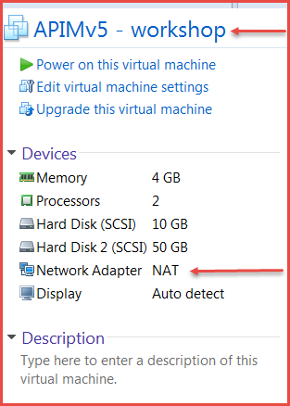

1. Power on the virtual machine (it will take a few minutes to boot, but you can continue with the next steps while you wait). **Select “I moved it” when prompted with if the image was copied or moved.**



##### API Connect Portal

1. Right click on the 5.0.0.0-APIConnect-Portal zip file, and unzip using a zip utility (winzip or 7-zip).
2. Go to VMWare Workstation. File 🡪 Open 🡪 Locate the vmx file that was unzipped (5.0.0.0-APIConnect-Portal.vmx).
3. You may be prompted with the following message, select “Take Ownership”.
4. Power on the virtual machine (it will take a few minutes to boot, but you can continue with the next steps while you wait). **Select “I moved it” when prompted with if the image was copied or moved.**
5. If you may get the message below, click **Yes** and continue to power on.

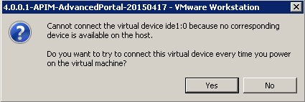

If you get the message, “Virtual device ide 1:0 will start disconnected” you can ignore the message.

### **FakeSMTP Setup**

1. Open a command window in the Ubuntu VM. Click on the Blue icon on the top left. Click terminal in the drop down list.

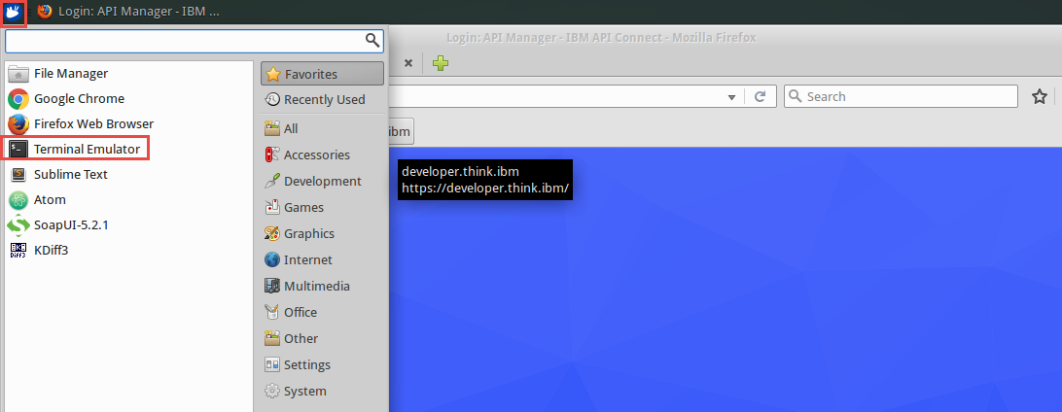

1. Key in java -jar /opt/fakeSMTP/fakeSMTP-2.0.jar

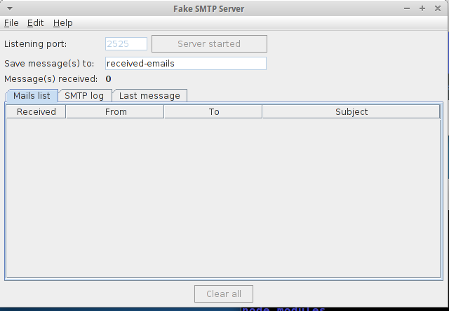

1. Click the **Start server button.**

#### 4 User ID and Passwords

The following are the admin user ID’s and password for the PoT images –

|  |  |  |
| --- | --- | --- |
| Image | User ID | Password |
| Xubuntu | admin | Passw0rd! |
| APIM | admin | Passw0rd! |
| Gateway | admin | Passw0rd! |
| Portal | admin | Passw0rd! |

Note – Student user ID’s and passwords will be provided in the student lab.

#### 5 Open Ubuntu Firefox to verify all API components are up

Once the Ubuntu image is up and running and all the other VM’s have been brought up in order. Go to the Ubuntu image and open up Firefox Web Browser.

1. Click on the blue icon on the top left of the screen.
2. Click on Firefox browser.

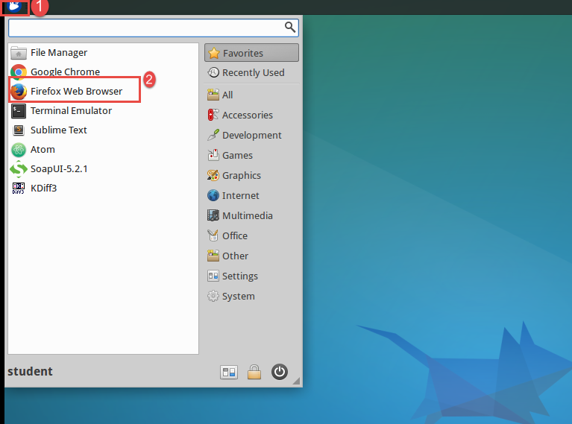

1. Shortcuts have been set up for all consoles on the Firefox Web Browser.

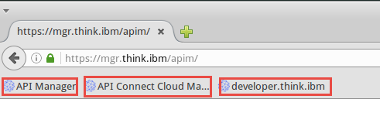

1. Click on each page above and make sure it comes up.
2. Students should now be ready to work on the labs.

#### Appendix A – Installing OVA from scratch

NOTE – Follow this section if you want to install and configure the API Connect environment from scratch.

Download the OVA files from the SAC and Fix Central to a staging folder:

• IBM DataPower Gateway Virtual Edition for Developers V7.5 Open Virtualization Format OVA package for VMWare English (CN9M7EN)

• NEED TO UPDATE LOCATION - 4.0.1.0-APIManagement-ManagementAppliance-20150623-1719_c87630891abc.ova (FC)

• NEED TO UPDATE LOCATION - 4.0.1.0-APIManagement-AdvancedPortal-20150514_1046.ova (FC)

The DataPower gateway server image is not included with the API Connect download files.

Download the DataPower GA release from SAC and then, if necessary, download any firmware update from Fix Central (select the fix that matches the appliance type and licensed features enabled on the appliance e.g. xi7001.oradco.scrypt4).

2. NEED TO UPDATE LOCATION Ubuntu Image- Download the compressed Ubuntu VMware image from https://drive.google.com/open?id=0BwYmwmFVWwRWRmVuN1BMbUtxTWs

to the same staging folder that you use for the OVA files. All the VMware is zipped and split into pieces of roughly 720MB.

Use a tool like 7-Zip, which is free open source software for Windows and Linux. It will unpack the Zip files. When doing the extract, point to the Virtual Machines folder where you plan to keep all the virtual machines (a total of 4) for this lab. I recommend using C:\Virtual Machines since VMware recommends this folder be a close as possible to the root drive.

#### 1 Configure the Gateway appliance

##### Install wizard (DataPower IDG v7.5)

|  |  |
| --- | --- |
| Description: sign-info | As you work with VMware, note the directions to click inside or press Ctrl+G to direct input to this particular VM console.  It is assumed that the VM is now started and there is a **login:** prompt. |

1. Log into the DataPower virtual appliance with username “admin” and password “Passw0rd!”.
2. Press any key to continue.
3. Enter “n” to enable disaster recovery mode
4. Enter “n” to disable common criteria compatibility mode
5. Enter and confirm your new admin password
6. Enter “y” to run the installation wizard
7. Enter “y” to configure network interfaces
8. Enter “y” to say you have all the information
9. Enter “y” to configure eth0
10. Enter “n” to disable DHCP
11. Enter the eth0 IP address from the Static IP addresses section in CIDR notation, (192.168.225.52/24). This assumes you are using NAT Addresses – see the appendix for info on how to check/amend NAT settings in VMware
12. Enter the IP address for the IPv4 gateway (192.168.225.2).
13. Press enter to skip the IPv6 gateway address.
14. Enter “n” to skip the eth1 configuration.
15. Enter “n” to skip the eth2 configuration.
16. Enter “n” to skip the eth3 configuration.
17. Enter “y” to configure network services
18. Enter “y” to configure DNS
19. Enter “y” to say you have all the information
20. Enter the IP address of the DNS server (same as the IPv4 gateway, 192.168.225.2)
21. Enter “n” to skip defining a unique system identifier for this appliance
22. Enter “y” to configure remote management access
23. Enter “y” to say you have all the information
24. Enter “y” to enable ssh
25. Press enter to accept the default IP address (all IP’s)
26. Press enter to accept the default port (22)
27. Enter “y” to enable the WebGUI
28. Press enter to accept the default IP address (all IP’s)
29. Press enter to accept the default port (9090)
30. Enter “n” to skip configuring a user account that reset passwords
31. Enter “n” to skip configuring a hard disk array
32. Enter “n” to skip reviewing the current configuration
33. Enter “y” to save the current configuration
34. Enter “y” to overwrite the previous configuration
35. **Important**: Do not log out of the console until you have logged in to the WebGUI and accepted the license (detailed in the next section). Otherwise, you have to work through the wizard again.  
    **Note**: To check the IP addresses you configured earlier you can run the command “show int”

**Note**: To check that AO is available and enabled you can run the command “show license” and look at “AppOpt”

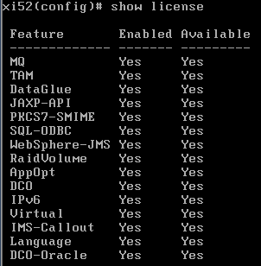

### Accepting the license

1. Navigate to the following URL in a browser: <https://192.168.225.52:9090/> (use the eth0 IP address)
2. Proceed through any security warnings about the self-signed certificate
3. Log in with username “admin”, password “Passw0rd!” and the default domain.
4. Click “I agree” to accept the license.
5. The appliance reloads. The next time you log into the console, the wizard is not displayed.

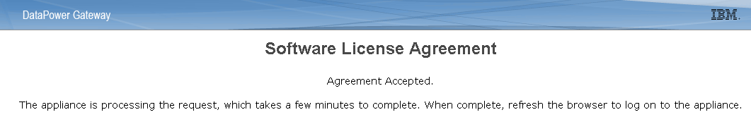

### Configuring NTP and timezone

It is **required** to configure NTP on every server to ensure the timestamps match and to avoid issues. Here is a [NTP server for the UK](http://www.timetools.co.uk/2013/07/25/ntp-server-uk/) and here is a [list for the US](http://tf.nist.gov/tf-cgi/servers.cgi). Others can be found by googling so just use one that is local to you. It is also recommended to set every appliance to the same timezone to make it easier to compare logs. I used UTC which is the default for the management server virtual appliance. Other values can be found [here](http://pic.dhe.ibm.com/infocenter/wsdatap/v6r0m0/topic/com.ibm.dp.xb.doc/name_timezone.html).

1. Log back into the WebGUI with username “admin”, the new password you specified and the default domain: <https://192.168.225.52:9090/> (it may take a few minutes for the appliance to reload before the WebGUI will be accessible again, refresh the URL until the login screen loads).
2. Select Network > Interface > NTP Service from the menu on the left
3. Set Administrative State to “enabled”
4. Set NTP Server = ntp.think.ibm (or other NTP server IP address) and click Add
5. Click the Apply button
6. Check that the object status changes to [up] at the top of the page.
7. Select Administration > Device > Time Settings and select EST.
8. Click Apply
9. Select Status > Main > Date and Time and verify the correct time and zone is displayed.
10. Click the Save Configuration link at the top right.

### Enabling the XML Management Interface Port

The XML Management Interface port must be enabled to allow IBM API Connect to configure the gateway server.

1. Select Network > Management > XML Management Interface
2. Set Administrative State to “enabled”
3. Set Local Address to the eth0 management IP address (192.168.225.52).
4. Keep the default port (5550)
5. Click the Apply button and the object status should change to [up] at the top of the page.
6. Click the Save Configuration link at the top right.

### Extend the Web Management Service idle timeout

This is an optional step that will stop you being logged out of the WebGUI after 10 minutes.

1. Select Network > Management > Web Management Service
2. Set the Idle Timeout to 6000 seconds or another large number of your choice.
3. Click the Apply button and the object status should change to [up] at the top of the page.
4. Click the Save Configuration link at the top right.

### Enabling statistics

The Statistics Service must be enabled in the Gateway Server to allow the Cloud Management Console to display resource utilisation information (more details in the [Knowledge Center](http://www-01.ibm.com/support/knowledgecenter/SSWHYP_3.0.1/com.ibm.apimgmt.cmc.doc/troubleshooting_graphs.html)).

1. Select Administration > Device > Statistic Settings
2. Set Administrative State to “enabled”
3. Click the Apply button and the object status should change to [up] at the top of the page.
4. Click the Save Configuration link at the top right.

### Upgrading to the latest Fixpack (if required)

1. If you need to update your DataPower OS, follow these steps otherwise, you can skip to the next section.
2. In the DataPower WebGUI, select Administration > Main > System Control
3. In the Boot Image section, click Upload and select the x*****.scrypt4 fixpack file.
4. Click the Continue button once the file has been uploaded successfully.
5. In the Boot Image section, ensure x*****.scrypt4 is selected, check the “I accept the terms of the license agreements” checkbox, and click the Boot Image button.
6. Click the Confirm button in the pop up window (you can ignore the warning “Firmware does not contain supported feature 'DCO-Oracle'.” since this is not required for APIM), wait for the action to complete and then click Close on the pop up window.
7. Wait for the system to reboot, and log back into the WebGUI (you can check the reboot output in the VMware console, the WebGUI should work once the login prompt is displayed).
8. Verify the version has been updated on the bottom left of the navigation menu on the left side of the screen.

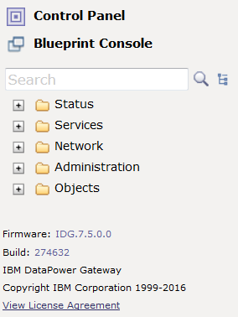

#### **2 Configure the Management appliance**

Once the APIM appliance is successfully started you will get a login prompt. The following instructions are for API Management V5.

Login with username admin and password Passw0rd!

Enter the following commands (one line at a time) to configure the networking and NTP. See Appendix A for further networking information.

Net set hostname static management

Net set domain static pot.ibm

net set eth0 address 192.168.225.100 mask 255.255.255.0

net set gateway static 192.168.225.2 eth0

net set nameserver static 192.168.225.2

net set ntp static 192.168.225.10 (If you use another NTP server, for example: pool.ntp.org, make sure to use the same value for the Gateway server)

time set zone America/New_York (If you need to set another time zone, key time help and follow the elaborate directions.)

net set search none

net restart (this may take a few minutes to complete)

net show all (if **Network is inactive** message appears, wait a little longer for the networking to restart fully and repeat this command until the correct details display)

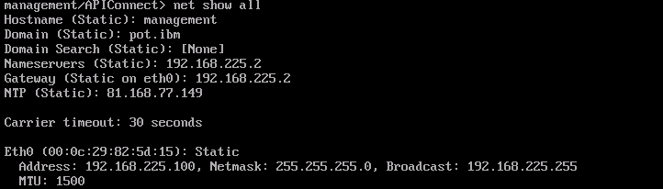

|  |  |
| --- | --- |
| Description: sign-info | Sometimes it takes several minutes for the CMC to come up after all of the system processes come up on the management server. If the CMC page comes up blank, wait a few minutes and reload the page. You can double check that all 3 key processes are up by typing system show status in the console window, but even if all are up it can take more time for the Web UI to become functional. |

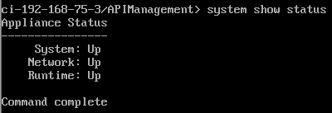

#### 3 Configure the API Cloud Management Console

At this point both appliances should be started.

Verify that both servers are set at the same time (within about 1 minute).

1. From the Gateway command window, key show time

2. From the APIM command window, key time show

3. Log into the Cloud Management Console: [https://192.168.225.100/cmc/](https://192.168.142.100/cmc/)

**Note**: Sometimes It takes roughly 3-5 minutes for the cmc to come up after all of the system processes come up on the management server. If the cmc page comes up blank, wait a few minutes and reload the page. You can double check that all 3 key processes are up by typing “system show status” in the console window, but even if all are up it can take more time for the UIs to work.

Accept any security trust exceptions that pop up.

4. When the login screen pops up, log in with Username admin and Password: Passw0rd!

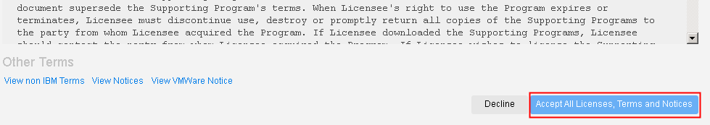

5. Click the **Accept All Licenses, Terms and Notices** button.

You will be required to change the admin password to something else upon logging in for the first time.

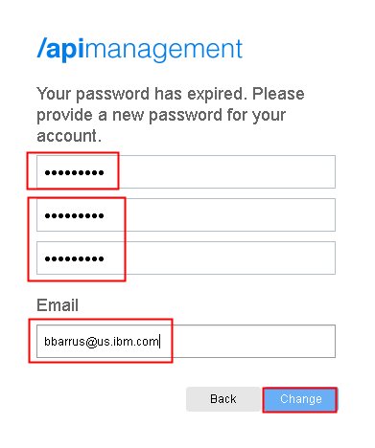

1. Key the current password and then key in the new password, Passw0rd! twice to make the change. Also enter a valid email account which you will need in the next steps. Click the **Change** button.
2. Go to Services. Verify that the **Management Service** display the correct **server name and Address.**

**Server Name** – management.think.ibm

**Address** – management.think.ibm

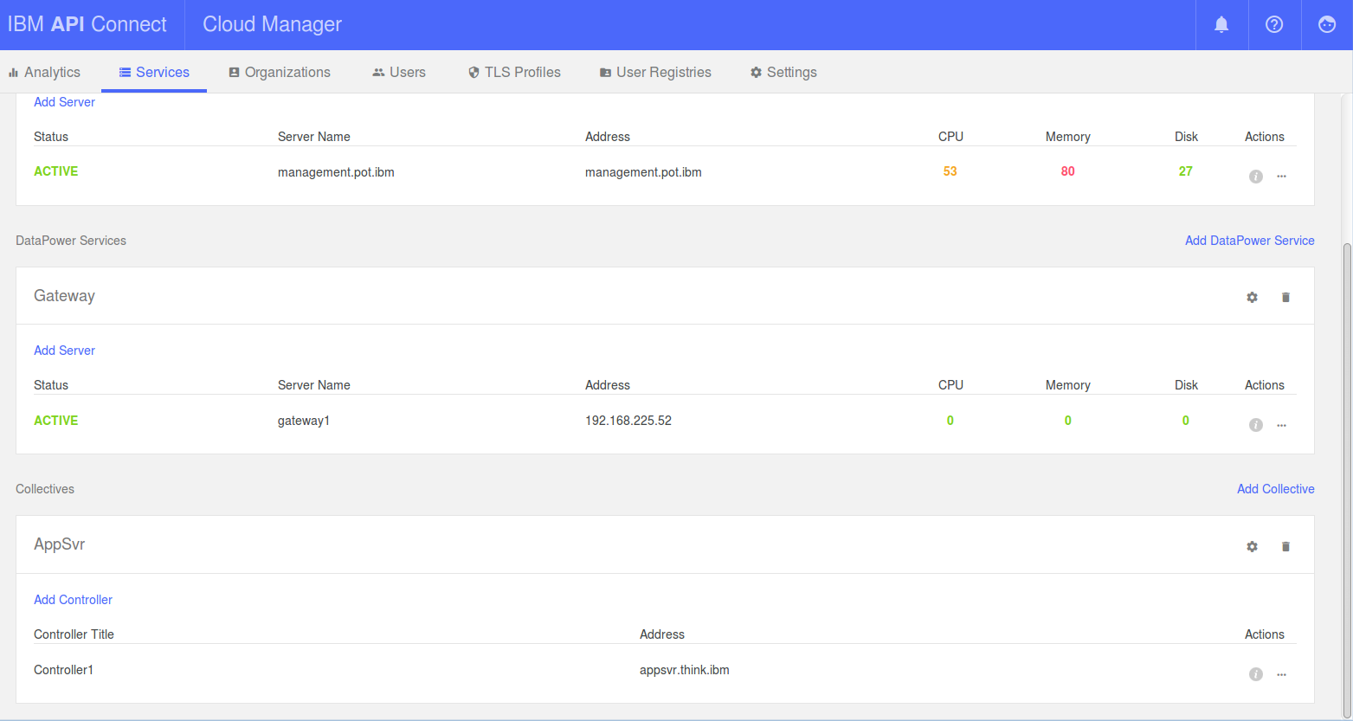

|  |  |
| --- | --- |
| Description: sign-caution | **If the correct IP address is not displayed, the system was not configured correctly during the initial boot (e.g. VM image was set to bridged and then changed to NAT after first boot).**  If this is the case, run the following commands from the command window:  system clean apiconfig  (You must type “yes” not “y” to confirm the system clean apiconfig command)  This procedure wipes the appliance configuration and the password is reset back to the default “!n0r1t5@C”  system restart  **Power off the VM**  **Power on the VM**  Return to **Step 6: Configure the Management appliance** and repeat the procedures starting with item 1 |

## Set up SMTP Server

1. Click on the Settings button and then fill in the information in the setup email box at the bottom of the page. The email server is used to send emails, for example, when a new organization account is requested. On your Host OS, it is recommended to use a stubbed out SMTP Server like FakeSMTP. Example gmail settings are provided in red.

Two examples are included below. You only need one to proceed to the next step. Feel free to use whatever SMTP server you prefer.

### Example 1: Use GMAIL SMTP

* 1. HOST NAME: <YourEmailHostName> (smtp.gmail.com)
  2. PORT: <YourEmailHostPortNumber> (465)
  3. USERNAME: Optional. If your email server requires you to authenticate, in the USERNAME field, enter the administrative user name for the SMTP server. (your gmail email address)
  4. PASSWORD: Optional. If your email server requires you to authenticate, in the PASSWORD field, enter the administrative password for the SMTP server. (your gmail password)
  5. SENDER ADDRESS: <EmailAddressForSendingEmails> (your gmail address)
  6. SENDER DESCRIPTIVE NAME: <DescriptionOfEmailSender> (e.g. My Sandbox Support)
  7. Click Save



* 1. You should receive a confirmation notice like the one below if your configuration is correct.
  2. Click **Test configuration**, fill out the form with a valid email address and click the **Send** button.

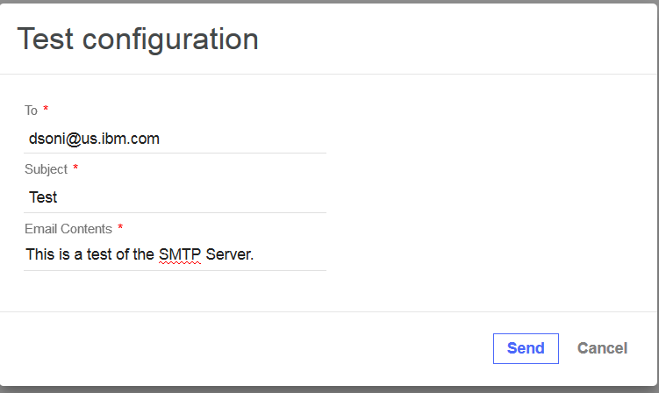

You should receive a confirmation notice and an email like the ones below if your configuration is correct.



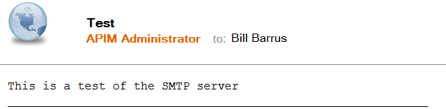

This confirms that it is working and ready when for the next step.

### Example 2: Use FakeSMTP

<http://nilhcem.github.io/FakeSMTP/>.

1. Open a command window in the Ubuntu VM.

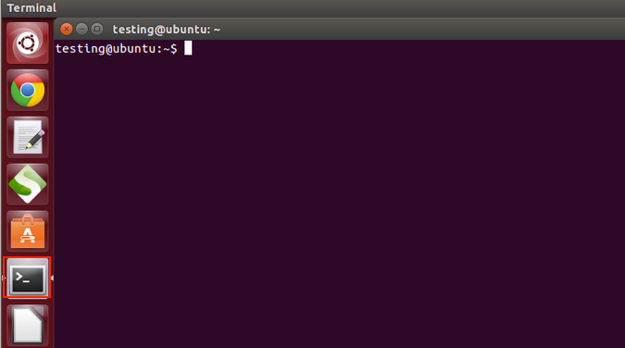

1. Key in java -jar fakeSMTP-1.13.jar



1. Click the **Start server button.**
2. Return to the Cloud Management Console Email section and enter in the values as depicted below:

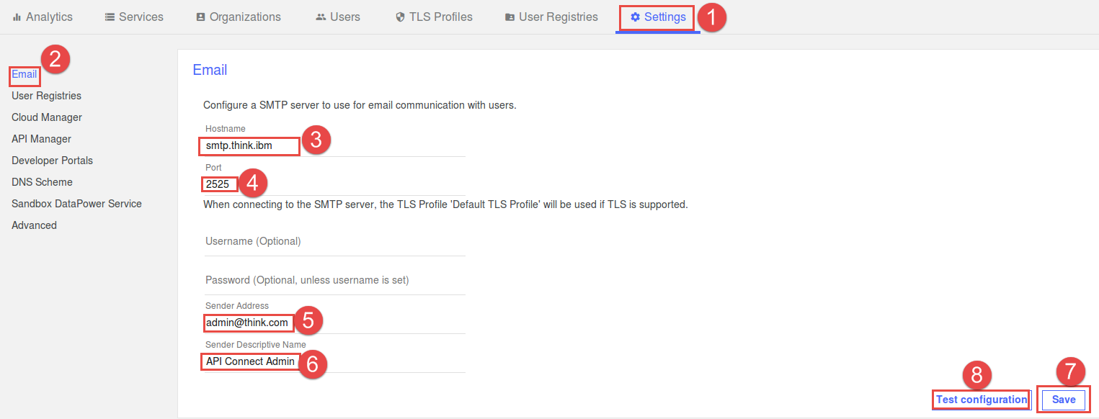

1. After clicking **Test configuration** you will see the following window. Fill it out and click **Send**

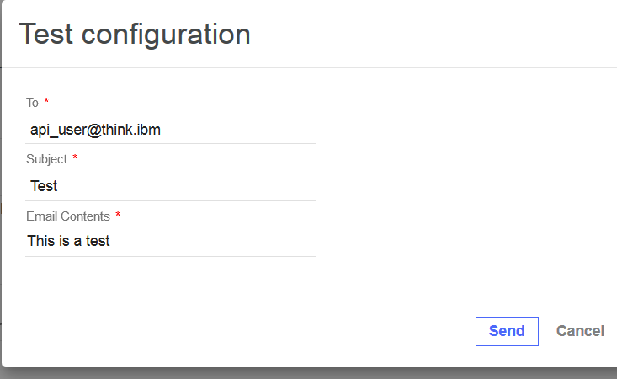

1. Return to the Fake SMTP Server and click the Last message tab and you should see the test message.

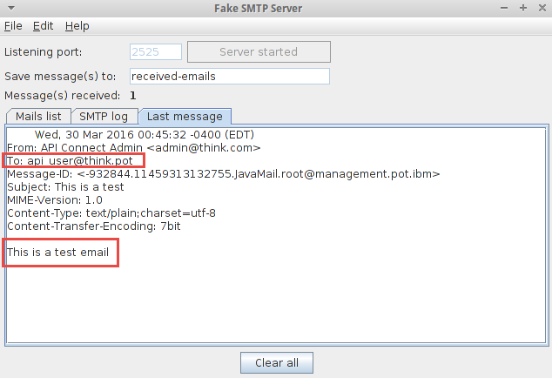

This confirms that it is working and ready when for the next step.

## Define Gateway Service

1. Define the clusters.
2. From the menu click on the icon
3. b. Modify your gateway cluster settings by click on the cogwheel on the lower right hand part of the screen

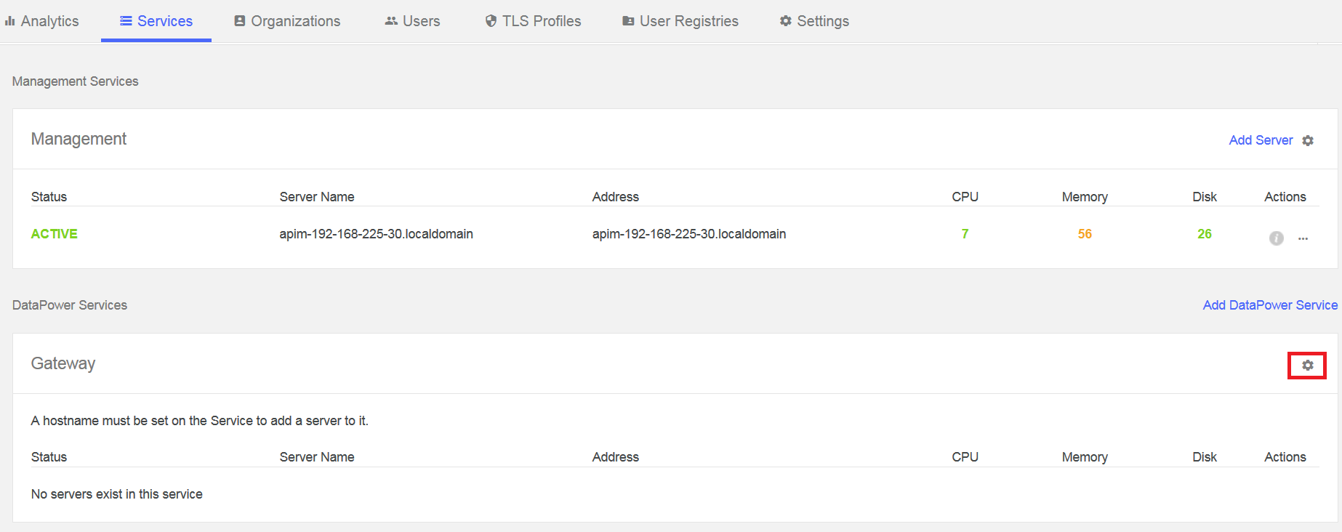

1. Enter the DataPower eth0 IP address or hostname in the Address box. (api.think.ibm).

d. Since this is a demo system, leave Load balancing selected as **External or no load balancer**.

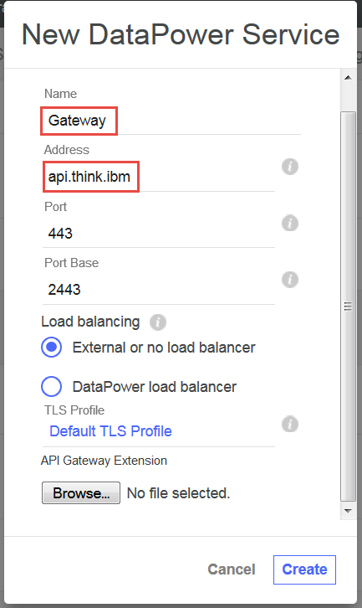

e. Leave the other values the same and Click **Save**

1. Add the Gateway server to the Cluster

Now it is time to add the DataPower gateway server to the gateway service.

* 1. Click on the Add Server button in the Gateway section.

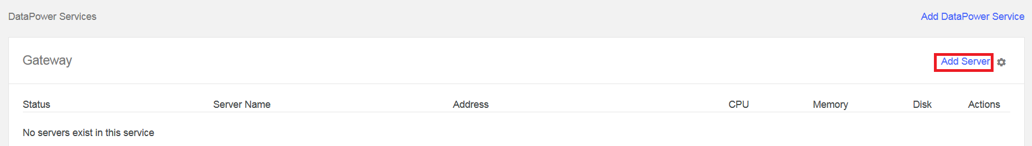

* 1. Enter in the information for the gateway server. Use the details for the XML Management Interface (Address 192.168.225.52, Port 5550, DataPower admin username and password) except for the Network Interface field which should be the interface to use for API traffic (eth0). The Name field is a free form text that will be visible in the Manage Servers Screen. Click Add when done.

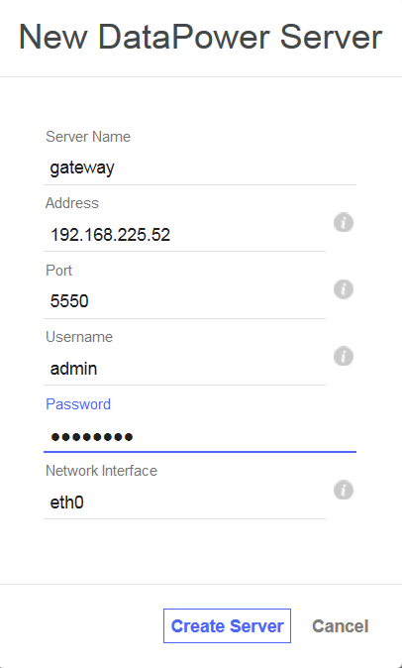

* 1. It takes a few minutes to add the server to the cluster. E.g. it needs to create the domain and the requisite DataPower assets. When it’s done, you’ll see the gateway server appear on the list

#### 4 Create the Provider Organizations

These items are performed in the Cloud Management Console.

1. Click on the **Organizations** button on the top menu of the CMC. Click on the **Add** **Organization** button to create the **Sales** organization. The Provider Organization would typically represent a department or project that would be defining APIs.



Enter the Organization title (sales) and short name (sales) as well as the email ([student@think.ibm](mailto:student@think.ibm)) of the owner.

Once you’ve entered all the details, click Add.

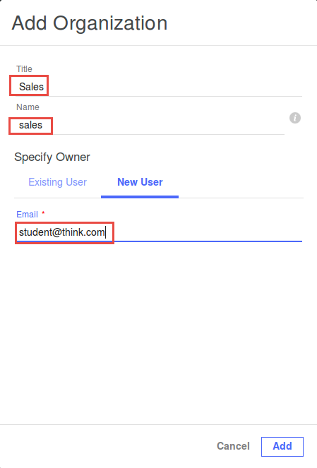

Copy and Paste the link into the browser or Click the link in your email to Activate your user account.

1. Since the email address for this lab example is not real, one way to view the invitation emails is to check the Last message tab of the fake SMTP Server console. If you use a real email address, this work around is not necessary.

Open the email link like the one below that contains an activation link (not the one that provides the URL to log into the account).

**Note:** If you are using Fake SMTP, click the **Mails list** tab and double click the email

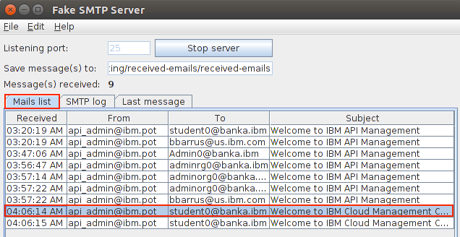

The email opens in a text editor window that allows you to cut and paste the URL from the **Edit** menu at the top of the screen.

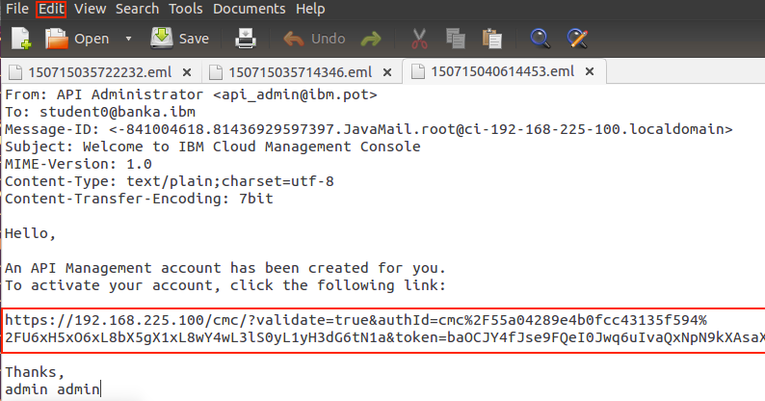

|  |  |
| --- | --- |
| Description: sign-caution | If the email never arrives, you can extract the link from the logs. To pull the log files, click on the **Services** on the top menu and click the download icon as indicated in the figure below.  Search the **cmc.out** log file found in **C:\Temp\apim-logs-management-ci-192-168-225-100-20150428T205248GMT.zip\var\log.** Search on **sales** and find “Email to” that was added to the email.  example:  Email to: somemail@gmail.com, URL: [https://10.91.25.19/cmc/?validate=true&authId=cmc%2F5527cc73e4b0b55fe4711add%2FI3xA3rT4oE2tW8jR0nM8tV0pI6mM7lW3tX2xU2tS0e&token=m5QfcGr3KHZacaZoC3TcnqffMGsNqJYefjHINu5Tmf&username=someemail%40gmail.com](https://10.91.25.19/cmc/?validate=true&authId=cmc%2F5527cc73e4b0b55fe4711add%2FI3xA3rT4oE2tW8jR0nM8tV0pI6mM7lW3tX2xU2tS0e&token=m5QfcGr3KHZacaZoC3TcnqffMGsNqJYefjHINu5Tmf&username=dhmaroju%40gmail.com) |

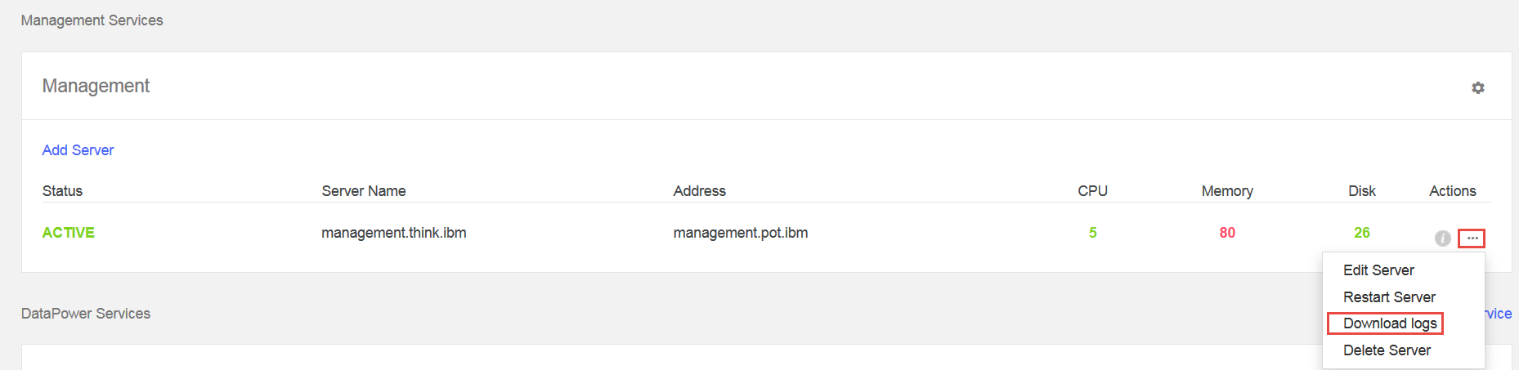

1. Click the link in the email to activate the account. Notice that the USERNAME is already indicated as **sales@think.ibm**. Key in the user information in respective input fields. Use the same password – *Passw0rd!* and click the **Sign Up** button.

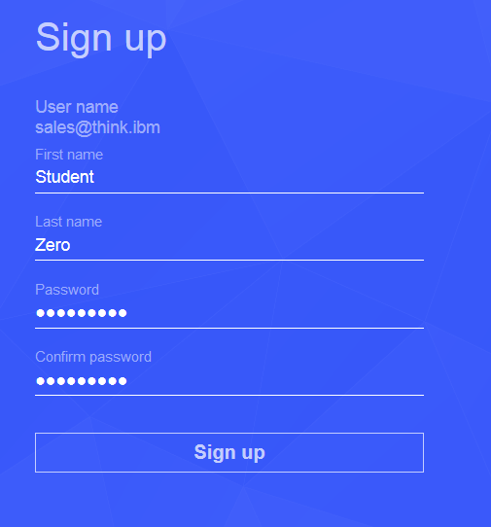

1. You will be automatically redirected to your new organization’s API Manager at <https://192.168.225.100/apim/>.
2. Log in with [student@think.ibm](mailto:student@think.ibm); password Passw0rd!
3. The following page will appear. Click “got it”.

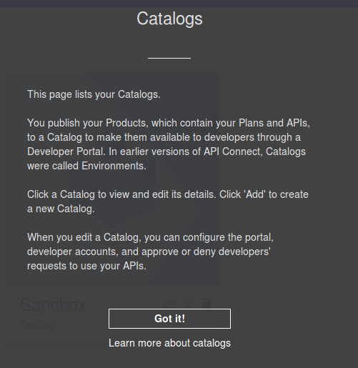

1. Setup of the management node is now Complete

#### 5 Configure the Advanced Developer Portal

At this point both gateway and management appliances should be started and configured.

1. Ensure that the Advanced Portal VM is started. If you get the following message, click **No** and continue on.

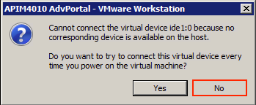

1. Log into the advanced portal using the default credentials of **admin /Passw0rd!** in the VMware console.
2. Change the networking for the eth0 interface on the portal by doing the following
   1. Type in **sudo nano /etc/network/interfaces**
   2. We will be focusing on the following sections in this file

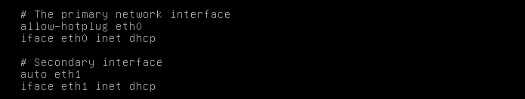

* 1. Change the Primary network interface information to the following:

**allow-hotplug eth0**

**iface eth0 inet static**

**address 192.168.225.20**

**netmask 255.255.255.0**

**gateway 192.168.225.2**

* 1. Comment out the two lines under secondary interface. The screen should appear like below.

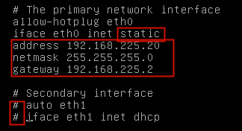

* 1. Key **Ctrl + x** to exit;  **y** to save the changes; **Enter** to write. Expect a response like:

**[Wrote 20 lines ]** and focus returns to thecommand line.

* 1. You will need to recycle networking by typing the following or reboot the VM. [In my case I had to reboot the VM every time]:

**sudo ifdown eth0**

**sudo ifup eth0**

**sudo /etc/init.d/networking stop**

**sudo /etc/init.d/networking start**

If all went well, expect to see:

**[ OK ] Configuring network interfaces . . . . done**

* 1. Issue the command **ifconfig** to verify that eth0 addressing is correct – **192.168.225.20**.



* 1. Add hostname entries for the management, gateway and porta into the /etc/hosts file on the developer portal via sudo vi /etc/hosts. Note there is a tab between the IP address and the hostname below.

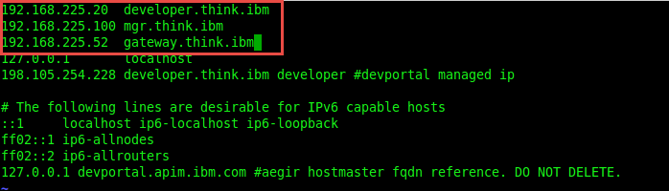

1. Via your browser, connect to the CMC portal and log in as the admin user. Go to the settings menu option. Select the Developer Portal section from the side menu.
   * 1. Enable Developer Portal by moving the slider to the right
     2. Enter in the Portal Management Address -> 192.168.225.20
     3. See screenshot on following page

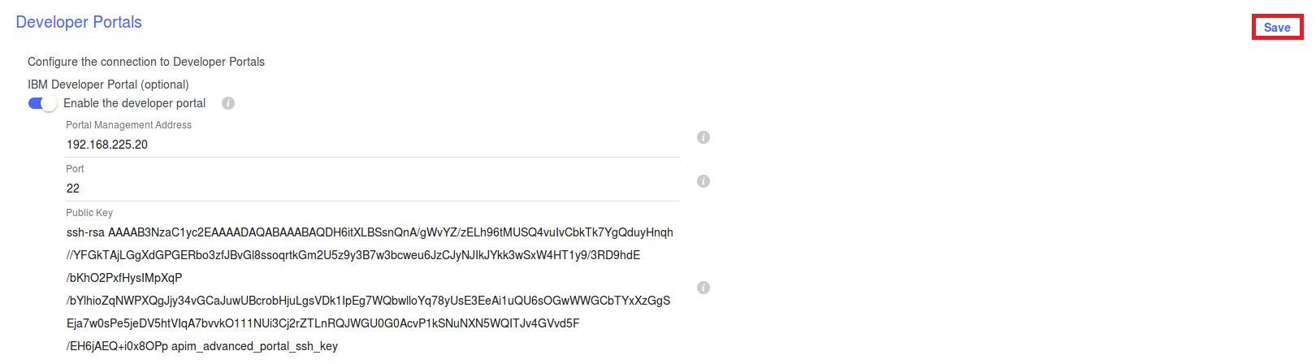

1. Copy the public key block of text from the same section to the clipboard by selecting it and typing CNTRL – C.
2. Go to your putty screen, type the following and then paste (mouse right click) the contents of the public key into the window

**echo “*contents_pasted_from_the_public_key_field"* > *key_file_name***

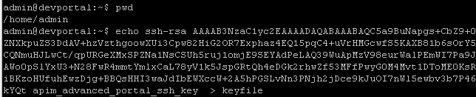

1. Based on the guide immediately below, execute the command to set the APIM host name:

**cat *key_file_name* | set_apim_host *devportal_host_name* *apim_cluster_address***

note the dev_portal_host_name needs to be the hostname of the Portal, which is developer.think.ibm

apim cluster address is the management node hostname. In this case, its mgr.think.ibm

1. Configure the SMTP server to be used to deliver the validation URL for the admin user. Ideally, you should be using something like FakeSMTP. To configure the SMTP server type the following:

**set_smtp <*mail_server_host_name>* <*port>* <*user* *password>***

for example (Fake SMTP):

**set_smtp smtp.think.ibm api_admin@think.pot Passw0rd!**

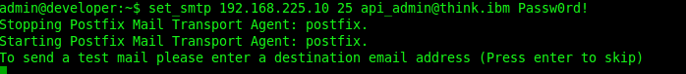 

Optionally you can send a test mail which should result in something like the following (in Fake SMTP).

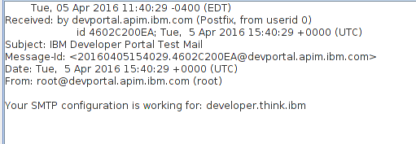

1. Next we will download the cert from the APIM node to this machine. This causes the Developer Portal to contact the configured Management cluster, download the SSL certificate and add it to the Advanced Developer Portal trust store.

Type the following in the command window: **download_apim_cert**

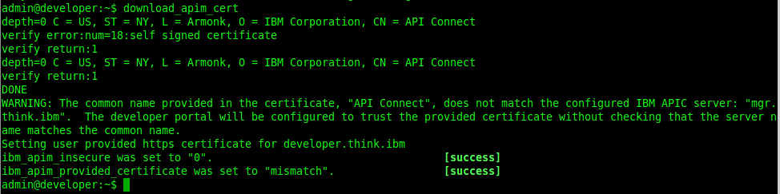

1. Type in: **set_apim_cert -i**

site

This will cause the **Advanced Developer Portal** to trust any SSL certificate served by the API Management node.

|  |  |
| --- | --- |
| Description: sign-caution | This should only be used for development and testing purposes as it is not secure and leaves the Advanced Developer Portal exposed to man-in-the-middle attacks. |

Now you can add the **Advanced Developer Portal** to your environment.

1. Go to the APIM url Management tab of your browser and log back in as **student@think.ibm / Passw0rd!**
2. Click the **Settings** button. The select **Portal**, select **IBM Developer Portal.** Type in host name as https://developer.think.ibm.

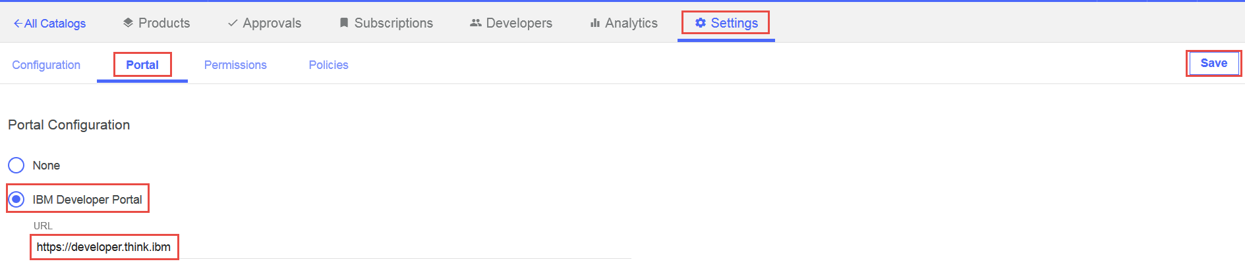

1. Click the **Save** button. This will create your initial environment. It will take a few minutes and you should get a validation email like the following (on Fake SMTP):

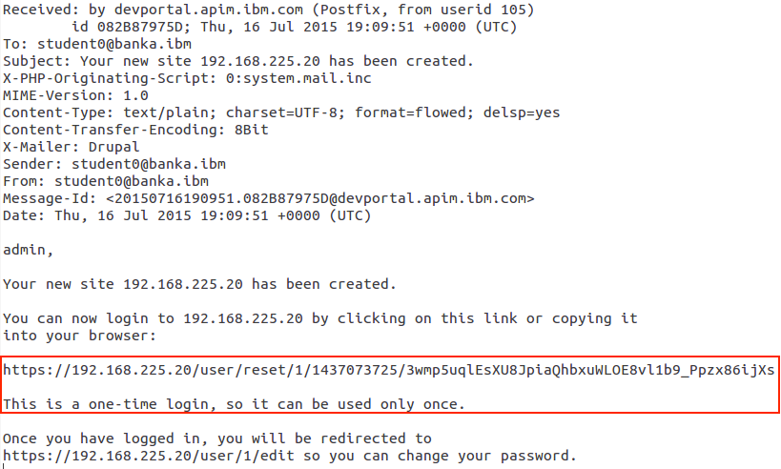

If you do not get the validation email, then you can go back to your Putty SSH window and type the following:

**list_sites**

It will give output that looks like this. The numeric value is the id of your portal site. 5522c89ce4b09cde299eb3ed.55258748e4b09cde299eb440 => 192.168.225.20

To get the link, copy and paste the numeric output of the previous command and run this command:

**site_login_link 5522c89ce4b09cde299eb3ed.55258748e4b09cde299eb440**

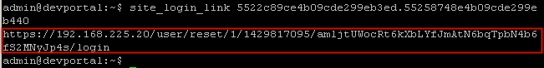

The output from the previous step includes the Advanced Developer Portal link:

1. Copy and Paste that link to your browser and finish setting up your Admin user. Accept the warnings and the certificate.

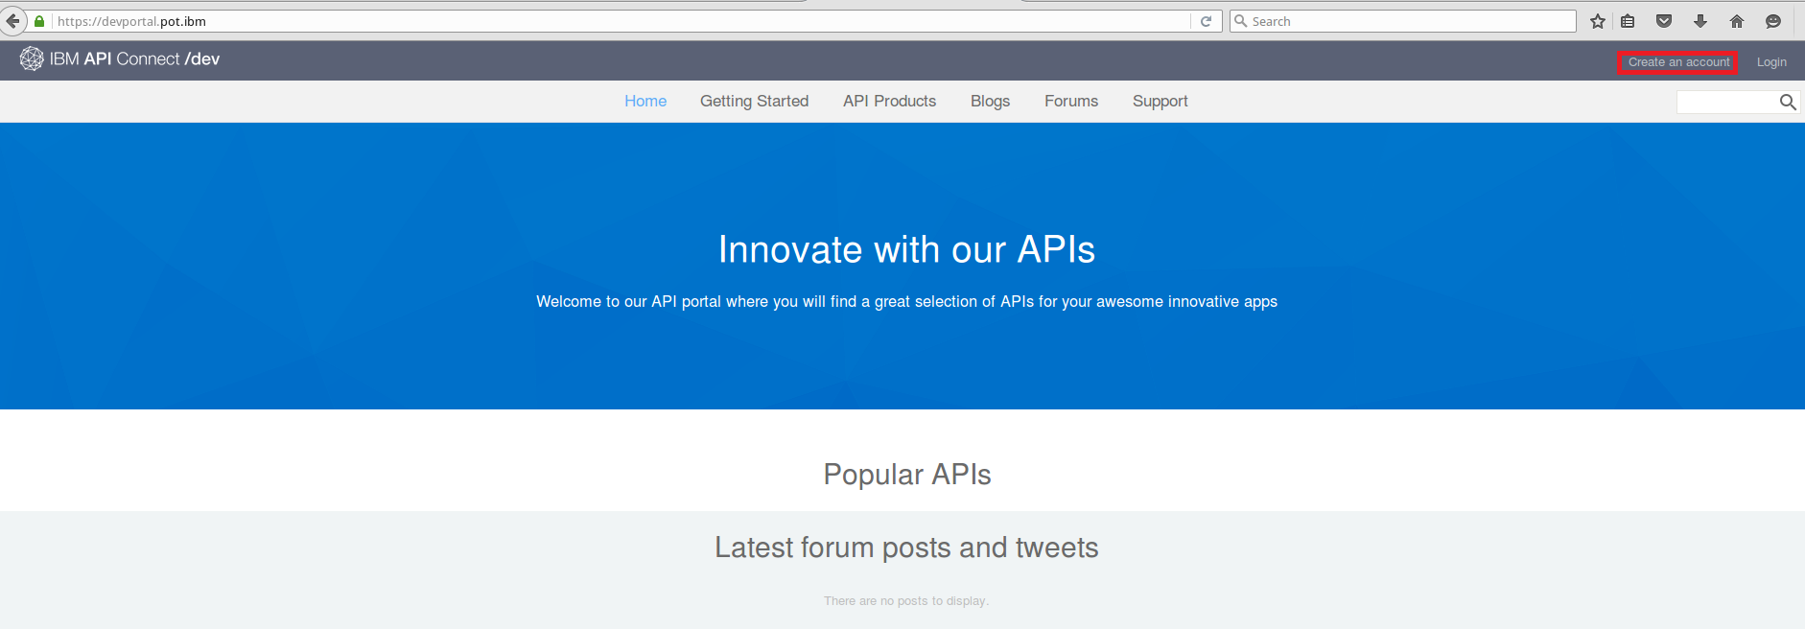

This is a one-time login that expires and mandates that you create a password.

1. Create and confirm the password as Passw0rd! .

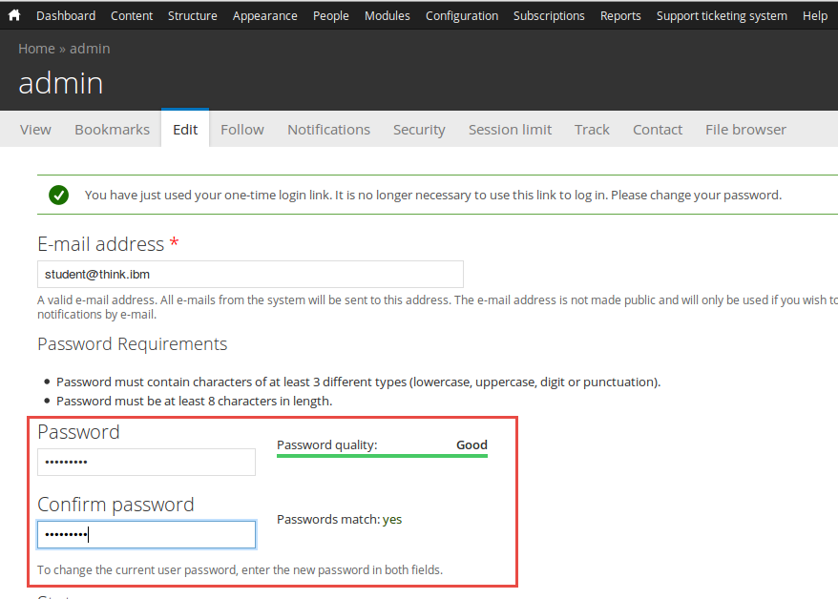

1. Add mandatory information denoted by *, that is your first and last name.
2. Uncheck **Force password change on next login**, set **Your current logout threshold** to 3600, and set the **Time zone** appropriately (America/New York).
3. Click the Save button at the bottom of the screen.

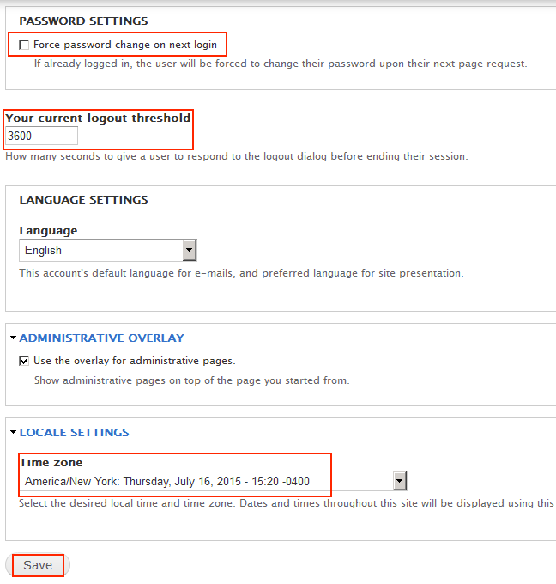

1. Since you have used this one-time link that is no longer valid close this window. Point your browser to the IP address of the Advanced Portal (192.168.142.20). The following window appears.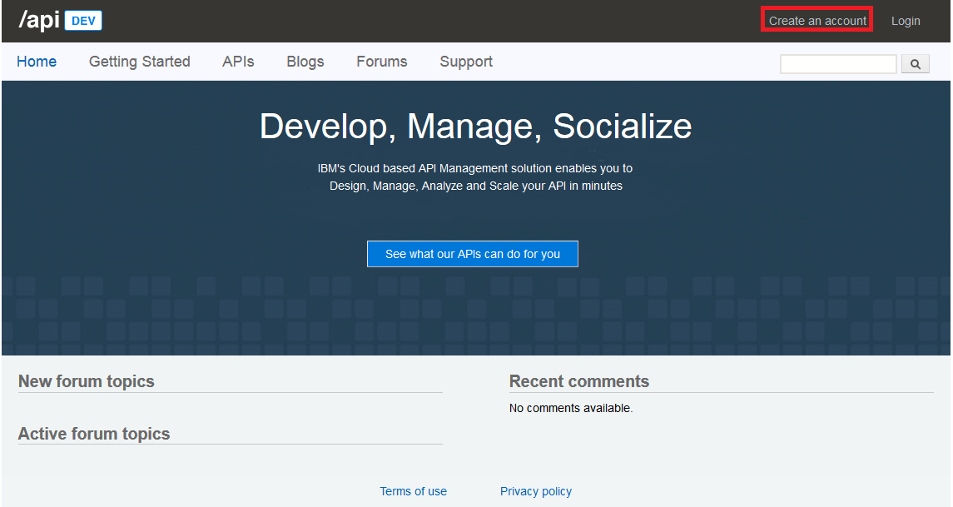
2. Create an API developer account by clicking on the **Create an account** link and filling out the user form with the following:

E-mail address: **developer@consumer.ibm**

Password: **Passw0rd!**

First Name: Mobile

Last Name: Developer

Organization: Mobile Developers

1. Click the **Create an account** link

You receive a message about an activation email.

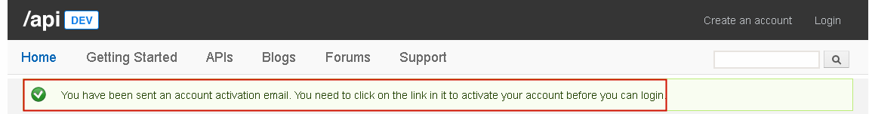

Here is the activation email that is sent using the email server defined inside of API Management (Fake SMTP example below).

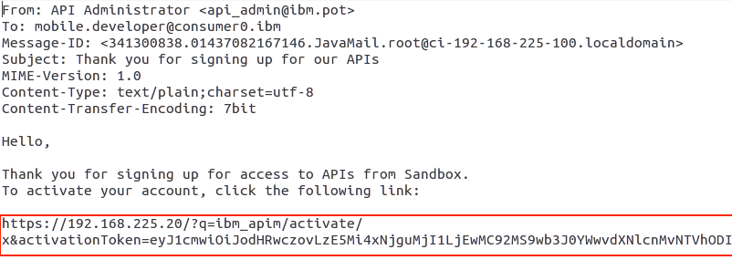

1. After directing your browser to the link in the email, validation begins. Login to **mobile.developer@consumer0.ibm** / **Passw0rd!** to complete the activation process.

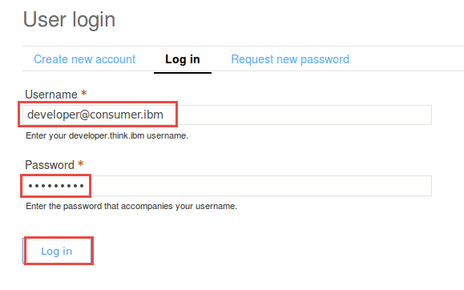

Here is Developer’s Home screen.

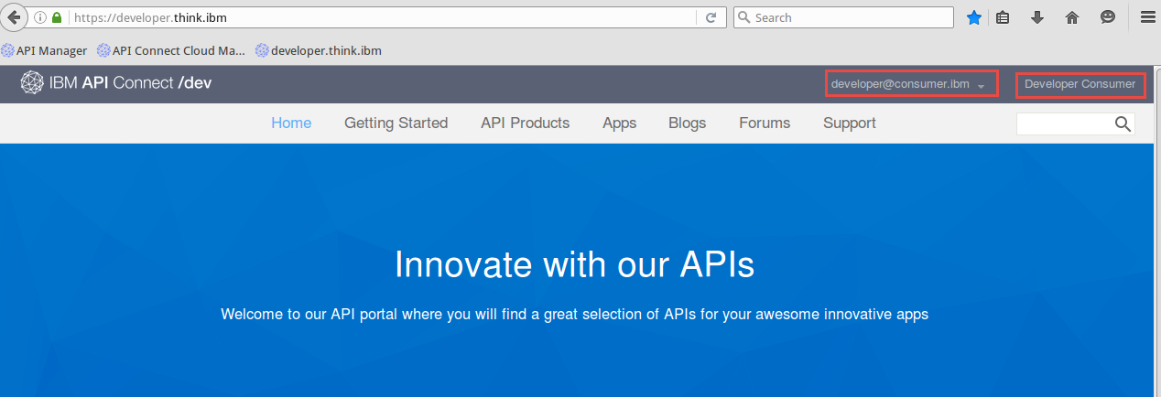

This concludes the process of setting up the API Management environment.

##### Congratulations!

You are ready to proceed to the PoT. See Appendix A – C for useful information that you might want to refer to during the labs.

The login info for the Cloud Management Console is **admin/Passw0rd!**

The login for the API Manager console is **student0@banka.ibm/Passw0rd!** or whatever email / password was used to set up the organization. In the labs substitute the proper email address as needed in place of student0@banka.ibm.

The login for the developer portal is **developer0@consumer.ibm / Passw0rd**!

**End of Setup**

#### Appendix B – VMware networking background information

##### Network configuration options

VMware offers [three options](http://pubs.vmware.com/workstation-9/index.jsp?topic=%2Fcom.vmware.ws.using.doc%2FGUID-D9B0A52D-38A2-45D7-A9EB-987ACE77F93C.html) for networking: bridged, NAT and host-only. We will use NAT so that IBM API Management will be able to make connections to endpoints or SMTP servers on the Internet (this isn’t possible with host only). Bridged networking requires static IP addresses to be assigned (or I’d have to reconfigure the networking every time new IP addresses were assigned by the DHCP server), and it would tie the configuration to a specific network.

##### Static IP addresses

When you install Workstation on Windows, a NAT network (VMnet8) is set up for you. IP addresses are typically assigned to virtual machines by using the virtual DHCP server included with Workstation. IP addresses can also be assigned statically from a pool of addresses that the virtual DHCP server does not assign.

From the VMware [documentation](http://pubs.vmware.com/workstation-9/index.jsp#com.vmware.ws.using.doc/GUID-FB6C0A06-CD5A-4E80-A405-B3A2B7D7236C.html): “In the default configuration, the virtual DHCP server dynamically allocates IP addresses in the range of *net*.128 through *net*.254, where *net* is the network number assigned to the NAT network. Workstation always uses a Class C address for NAT networks. IP addresses *net*.3 through *net*.127 can be used for static IP addresses. IP address *net*.1 is reserved for the host virtual network adapter and *net.2 is reserved for the NAT device*.

In addition to the IP address, the virtual DHCP server on the NAT network sends out configuration information that enables the virtual machine to operate. This information includes the default gateway and the DNS server. In the DHCP response, the NAT device instructs the virtual machine to use the IP address *net*.2 as the default gateway and DNS server. These routings cause all IP packets destined for the external network and DNS requests to be forwarded to the NAT device.”

#### Appendix C - Troubleshooting

##### Binary translation is incompatible with long mode on this platform. Disabling long mode

This error may occur when you open the virtual machine because Intel Virtualization Technology (VT) is disabled by default, in the BIOS of the Lenovo ThinkPads.

To resolve this issue:

1. Shutdown the laptop
2. Start the laptop
3. Once the ThinkPad splash screen appears, press the F1 or ThinkVantage key to enter the BIOS (the correct key to use will be displayed on the screen)
4. Within the BIOS, choose Security > Virtualization
5. Change “Intel (R) Virtualization Technology [Disabled]” to Enabled
6. Save and Exit from the BIOS

##### Handy Command Line Interface commands

###### Gateway Appliance (DataPower) Network

From the DP cli issue the commands

**show int**    -  Ensure that eht0 is set per setup instructions

**show time** -  to make sure that the NTP is working OK and the time matches the APIm Server

**show xml-mgmt**  - to make sure that xml-mgmt [up] displays with port 5550

**show time**  - make note of the time

**show ntp** - to show the NTP server settings

###### Management Appliance Network

From the Cloud Management Console window issue the command:

**net show all**   - check that the correct values are selected:

**time** **show** - ensure that the time matches the Gateway appliance time

**net ping 192.168.225.52** to ensure connectivity with DP

**Organizations**

If student creates an Organization before getting everything correct, then the following commands are required, since the database is likely corrupted:

**system clean apiconfig** [resets the appliance to factory defaults- password and Orgs wiped!]

**system restart**

**system show status** after about 5 minutes to confirm that all is up OK

#### Appendix D - Startup procedures and optional steps to make things easier

###### Open and start the DataPower and API Manager virtual machines

The following steps will guide you through loading and starting the DataPower and API Manager virtual machines if they are not already started.

1. From within VMWare Workstation, select: File🡪Open…
2. Navigate to the “API Gateway” folder, left click **GW_4001_PoT.vmx** and click **Open with VMware Workstation**.
3. Click the green start button labeled “Power on this virtual machine”.
4. 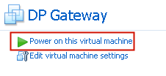
5. Navigate to the API Manager” folder, left click **APIMv4.0.0.1_PoT.vmx** and click **Open with VMware Workstation**.
6. Click the green start button labeled “Power on this virtual machine”.

###### Verify connectivity to the two virtual appliances

In this step, you’ll verify that both the Gateway VM (DataPower) and the API Manager VM have successfully started.

|  |  |
| --- | --- |
| sign-info | Be Patient. It takes several minutes before both VM’s have fully started.  Even though the API Manager VM may have a login prompt, it may still be initializing the various subsystems. |

|  |  |
| --- | --- |
| sign-info | Untrusted site alert  In the following steps, you may receive a browser alert warning that the site is untrusted. Please follow the directions to accept the risk or confirm the security alert. |

First, verify that the Gateway node has started.

1. Open an Internet browser and enter the address: [https://192.168.225.52:9090](https://192.168.142.52:9090)
2. You should see the DataPower WebGUI login
3. Open another browser window and enter the address: [https://192.168.225.100/cmc](https://192.168.142.100/cmc)
4. You should see the login window for the API Manager Cloud Management Console

###### Optional convenience settings

There are a few more things that can be done to help improve the PoT experience for the participants.

* Create bookmarks in the various browsers for the API Manager and DataPower gateway (see table 2 below)
* Add HOST entries for API Manager and the API Gateway nodes (see table 3 below)
* Set the browser home page to either:
  + [www.ibm.com](http://www.ibm.com)
  + [www.ibm.com/software/products/en/api-management](http://www.ibm.com/software/products/en/api-management)

Table 2 Recommended browser bookmarks

|  |  |
| --- | --- |
| Bookmark Label | URL |
| API Manager | <https://mgr.think.ibm/apim/> |
| API Manager CMC | <https://mgr.think.ibm/cmc/> |
| IBM DataPower Gateway | <https://dp.think.ibm:9090> |

#### Appendix E - Enable the Windows host NTP service (optional)

*This section is now deemed optional since the introduction of the Ubuntu Linux server that includes a preconfigured NTP server.*

A Network Time Protocol (NTP) server is used by both the DataPower and API Manager appliances in order to keep their time synchronized. Windows 7 includes an NTP server; however it is not enabled by default. In this section, you will enable the Windows Time Service

To enable the Windows NTP service, two registry keys must be modified. The following steps will guide you through modifying the Windows registry to enable the NTP service.

1. Click Start, click Run, type regedit, and then click OK.
2. Locate and then click the following registry entry:
3. HKEY_LOCAL_MACHINE\SYSTEM\CurrentControlSet\Services\W32Time\Config\
4. In the right pane, right-click AnnounceFlags, and then click Modify.
5. In the Edit DWORD Value (Hex) dialog box, under Value data, type 5, and then click OK.
6. Locate and then click the following registry subkey:
7. HKEY_LOCAL_MACHINE\SYSTEM\CurrentControlSet\Services\W32Time\  
   TimeProviders\NtpServer\
8. In the right pane, right-click Enabled, and then click Modify.
9. In the Edit DWORD Value (Hex) dialog box, type 1 under Value data, and then click OK.
10. Exit Registry Editor.
11. At a command prompt, type the following commands to restart the Windows Time Service:
    1. net stop w32time
    2. net start w32time
12. Go to Windows Services applet and set **Windows Time** to ‘Automatic (Delayed Start)’

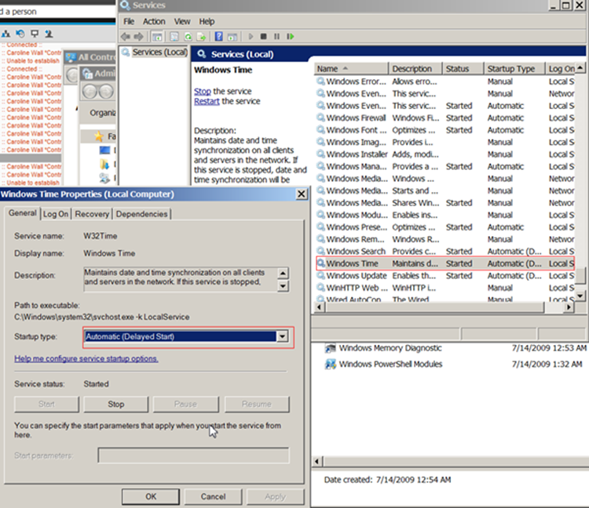

#### Appendix F - VMWare Fusion setup on Mac

This procedure is written for a MacBook Pro. Make sure that you have a model with 16 GB RAM. Ensure that each of the four VMs is set to NAT networking with the correct configuration per this document.

1. From the host system select **Vmware Fusion** / **Preferences**
2. Select **Network**

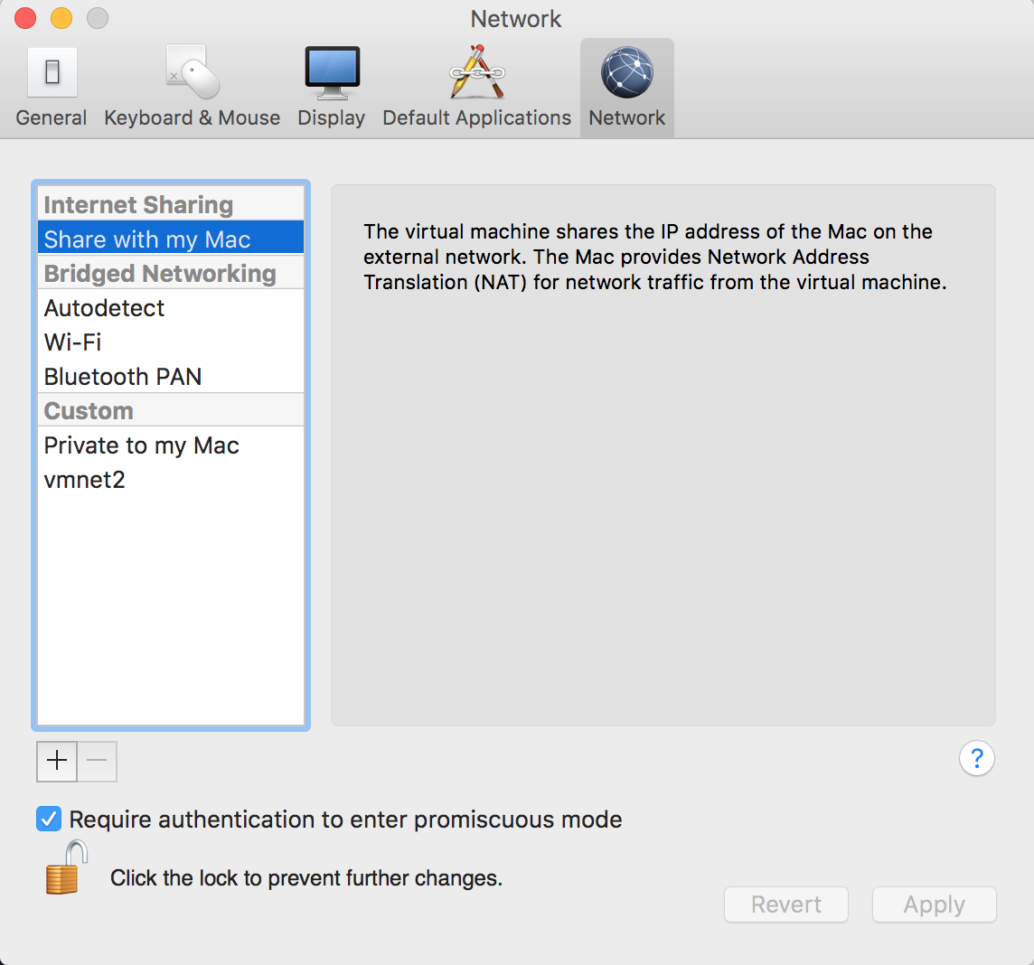

1. Select **Share with my Mac** for the host system.

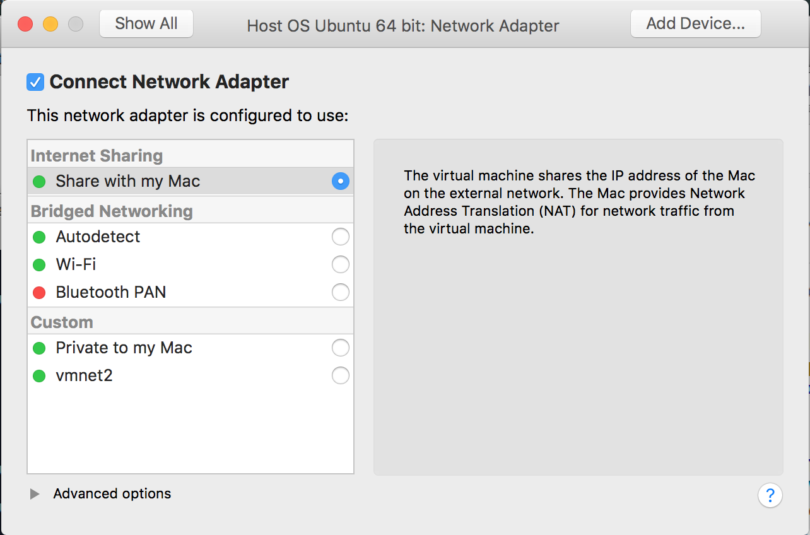

1. Verify VMNET is setup correctly by keying the following from the command line of the Mac:

**cat /Library/Preferences/Vmware\ Fusion/networking**

bills-mbp:Preferences billbarrus$ cat /Library/Preferences/Vmware\ Fusion/networking

VERSION=1,0

answer VNET_1_DHCP yes

answer VNET_1_DHCP_CFG_HASH E9CFC623CF46430FB45B927A05E378C49316393B

answer VNET_1_HOSTONLY_NETMASK 255.255.255.0

answer VNET_1_HOSTONLY_SUBNET 192.168.218.0

answer VNET_1_VIRTUAL_ADAPTER yes

answer VNET_8_DHCP yes

answer VNET_8_DHCP_CFG_HASH 9C0953A01DE93220B621CE655A775569C576DF1B

answer VNET_8_HOSTONLY_NETMASK 255.255.255.0

answer VNET_8_HOSTONLY_SUBNET 172.16.145.0

answer VNET_8_NAT yes

answer VNET_8_VIRTUAL_ADAPTER yes

bills-mbp:Preferences billbarrus$

By default, the subnet is set to 172.16.145.0.



1. Change the host NAT subnet by editing the file using this command from the terminal window of the Mac:

sudo nano /Library/Preferences/VMware\ Fusion/networking

1. Modify the SUBNET to 192.168.225.0
2. Press Ctrl + X to exit. When prompted, press Y to save.
3. Restart Fusion to restart the networking service.
4. If you have any running VMs prior to this change you will need to do a Shutdown - Not Suspend!! and then Start to reinitialize the network adapters.

Optional – Verify VMNET is setup correctly like the image below -

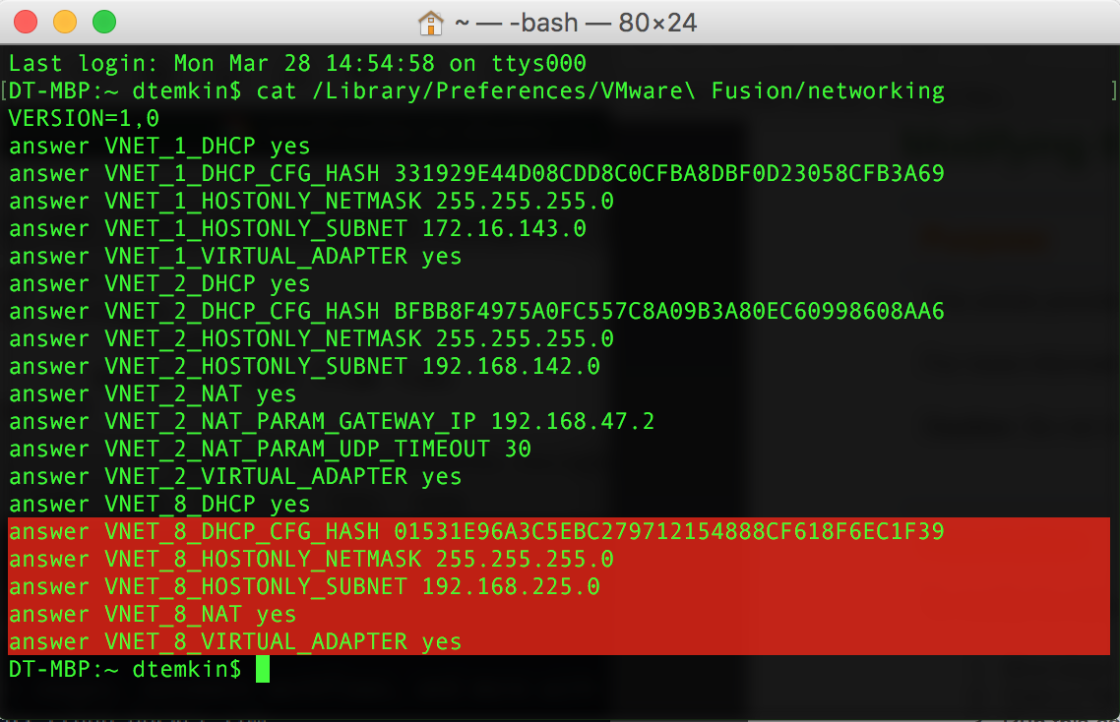



© Copyright IBM Corporation 2016.

The information contained in these materials is provided for informational purposes only, and is provided AS IS without warranty of any kind, express or implied. IBM shall not be responsible for any damages arising out of the use of, or otherwise related to, these materials. Nothing contained in these materials is intended to, nor shall have the effect of, creating any warranties or representations from IBM or its suppliers or licensors, or altering the terms and conditions of the applicable license agreement governing the use of IBM software. References in these materials to IBM products, programs, or services do not imply that they will be available in all countries in which IBM operates. This information is based on current IBM product plans and strategy, which are subject to change by IBM without notice. Product release dates and/or capabilities referenced in these materials may change at any time at IBM’s sole discretion based on market opportunities or other factors, and are not intended to be a commitment to future product or feature availability in any way.

IBM, the IBM logo, and ibm.com are trademarks of International Business Machines Corp., registered in many jurisdictions worldwide. Other product and service names might be trademarks of IBM or other companies. A current list of IBM trademarks is available on the Web at “Copyright and trademark information” at www.ibm.com/legal/copytrade.shtml.

